Experiment Analysis

Context:
Twitter offers a platform for businesses to create advertising campaigns aimed at increasing brand awareness and product adoption. Advertisers set a budget for their campaigns, and they are only charged for actual clicks on their ads. However, a delay between ad serving and click reporting can lead to overspending, where advertisers are billed for clicks exceeding their budget. For instance, if a campaign has $10 left and generates clicks worth $20, $10 is considered wasted.

Recently, Twitter has noticed an increase in overspending and decided to test a new ad product where advertisers pay for ad impressions rather than clicks, aiming to reduce latency in billing. To evaluate this new product, an A/B test was conducted, splitting advertisers into two groups: one using the traditional click-based model and the other using the impression-based model. After a week, Twitter aims to analyze the data to determine the success of the experiment.

Overview of Results:

Problem | Result of analysis | Insights
What is number of campaigns in treatment and control group that have spent more than 1% | Treatment False-5716  Treatment True-5180
Is the new product effective at reducing overspend.the average overspend percentage for campaigns in both the control and treatment groups | The median overspending is less in the Treatment group compared to the control group. | Product is effective overall.  Overspending: Treatment group (17.6%), control group (25.3%)
Was it more or less effective depending on the company size | The median overspending is less in the treatment group of small and large companies size but not in medium size companies | Product is working well or small and large companies but not (statistically) in medium sized companies
Are certain advertisers in the treatment group entering lower budgets | There is a statistically significant drop in budget in the treatment group but only in small companies. | Significant drop of budget in treatment ($1585.48) vs control ($3538.66) on avg  for small companies.
Is the variance different in treatment and control group. | There is a variance difference in small and large company size but not for medium size in the 2 groups.  No significant difference in variance overall. | Size: small, Significant difference.  Size: medium,  No significant difference.  Size: large, Significant difference.

Questions with detailed analysis and solution:
- How many campaigns have overspent of greater than 1% of their budget in the control group? In the treatment group?

To do that first we will need to create a new column named overspent_percent as shown below
df["overspent_percent"]=((df["campaign_spend"]-df["campaign_budget"])/df["campaign_budget"])*100
df.head()
After that we can use the following query to find overspent in control group (5716) and treatment group (5180)

# Filter for overspent > 1%
overspent_df = df[df['overspent_percent'] > 1]

# Count per group
overspent_counts = overspent_df['treatment'].value_counts()
overspent_counts

The output of the code will be:
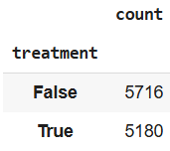
Here is the visualisation of the same:
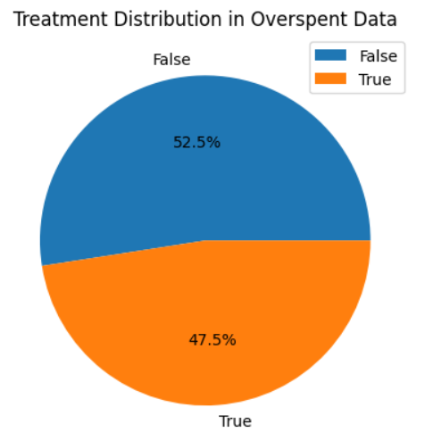
- Was the new product effective at reducing overspend, and was it more or less effective depending on the company size? Put together an analysis describing how the treatment affected overspend.

To see if the product is effective we need to run a statistical test.
First we check if the distribution of each group is normal or not using Q-Q plot
(for larger dataset >5000 Shapiro’s test is not accurate). The code for that is the following:
treatments = df["treatment"].unique()

plt.figure(figsize=(8, 4))

for i, treatment in enumerate(treatments, 1):
plt.subplot(1, 2, i)
data = df[df["treatment"] == treatment]["overspent_percent"]
stats.probplot(data, dist="norm", plot=plt)
plt.title(f"Q–Q Plot | Treatment = {treatment}")

plt.tight_layout()
plt.show()
The output is the following:
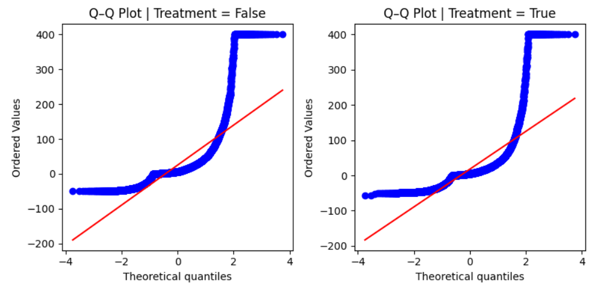
Now we will use MannWhitneyU test to see if the difference is significant statistically:
# using Mann–Whitney U test to check if overspent_percent is greater in control group than treatment
# H0: Median (control) ≤ Median (treatment)
# H1: Median (control) > Median (treatment)

group_false = df[df["treatment"] == False]["overspent_percent"]
group_true = df[df["treatment"] == True]["overspent_percent"]

stat, p_value = stats.mannwhitneyu(group_false, group_true, alternative='greater')

print(f"p_value: {p_value:.4f}", " significant difference" if p_value < 0.05 else " no significant difference")
The output is following:
To see if the product is effective at company size level first we check if the distribution of each group is normal or not. The code for that is the following:
treatments_iter=df["treatment"].unique()
company_iter=df["company_size"].unique()

for company_size in company_iter:
for treatment in treatments_iter:
stat, p_value=stats.shapiro(df[(df["company_size"]==company_size) & (df["treatment"]==treatment)]["overspent_percent"])

print(f"company size: {company_size},treatment: {treatment}, p_value:{p_value:.2f}", "normally distributed" if p_value>0.05 else "not normally distributed")
The outcome will be the following:
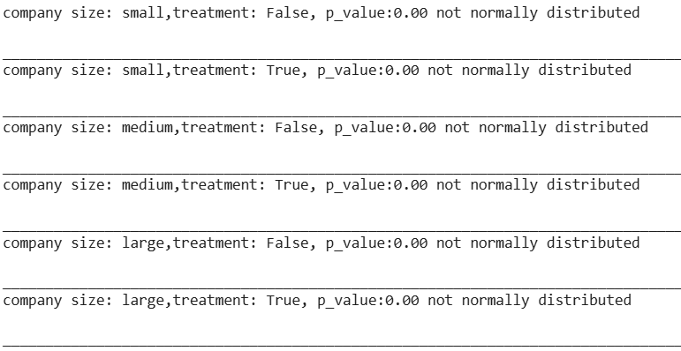
Clearly none of them is normally distributed.
Lets verify it once using hisplot using the following code:

n_rows = len(company_iter)
n_cols = len(treatments_iter)

fig, axes = plt.subplots(n_rows, n_cols, figsize=(10, 8))

for i, company_size in enumerate(company_iter):
for j, treatment in enumerate(treatments_iter):
subset = df[(df["company_size"] == company_size) & (df["treatment"] == treatment)]["overspent_percent"]

# Shapiro wilk's test to check if normal
stat, p_value = stats.shapiro(subset)
normality = "normally distributed" if p_value > 0.05 else "not normally distributed"

ax = axes[i, j]
sns.histplot(subset, kde=True, bins=30, ax=ax)
ax.set_title(f"{company_size} | {treatment} | {normality}")
ax.set_xlabel("overspent_percent")
ax.set_ylabel("Frequency")

plt.tight_layout()
plt.show()

The outcome of the code will also reflect that the distribution of each group is skewed and some have more than 1 peaks
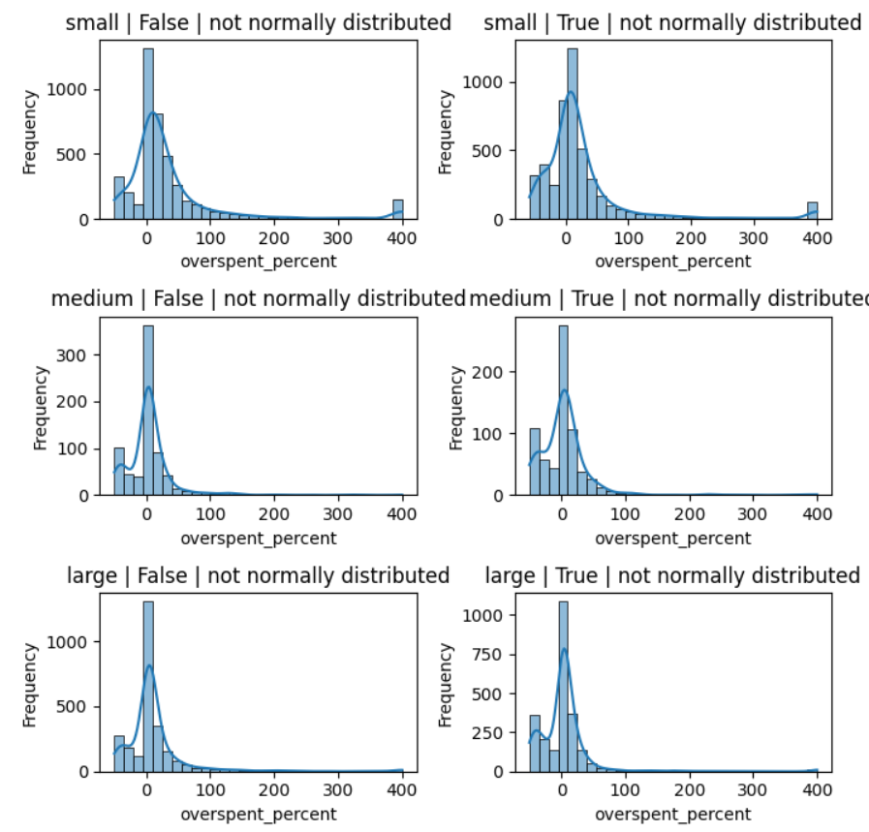
We tried to use log transformation but even then the distribution was not normal.
So it is clear to us that we need to use Mann–Whitney U test instead of T test to see if the difference is statistical difference significant
#using Mann–Whitney U test
# H0: median is same for treatment and control
# H1: median is NOT same for treatment and control

for company_size in df["company_size"].unique():
group_false = df[(df["company_size"] == company_size) & (df["treatment"] == False)]["overspent_percent"]
group_true = df[(df["company_size"] == company_size) & (df["treatment"] == True)]["overspent_percent"]
stat, p_value = stats.mannwhitneyu(group_false, group_true, alternative='greater')
print(f"company size: {company_size}, p_value: {p_value:.4f}", " significant difference" if p_value < 0.05 else " no significant difference")
The output is clear:
For small and large companies, there is a significant difference. But for medium size companies that is not the case.
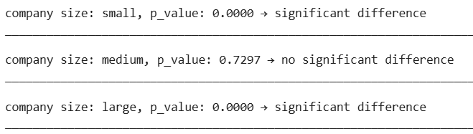

- A product manager on the team is concerned that certain advertisers in the treatment group are entering lower budgets because they are wary of the new product. Provide some evidence to support their suspicions, or show that any differences in budgets are likely due to random fluctuations.

First we see the mean of budget by company_size and treatment using the following code:
budget_comparison = pd.crosstab(df["treatment"], df["company_size"], values=df["campaign_budget"], aggfunc="mean")
Budget_comparison
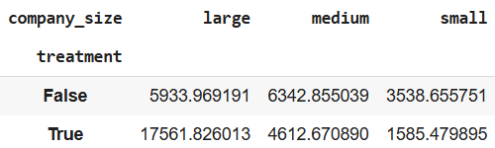
We also visualise this using box plot using the following code:
plt.figure(figsize=(6, 4))
sns.boxplot(data=df, x="company_size", y="campaign_budget", hue="treatment", showfliers=False) #showfliers is a parameters that hide outliers and by default is True
plt.title("Campaign Budget by Company Size (Treatment vs Control)")
plt.xlabel("Company Size")
plt.ylabel("Campaign Budget")
plt.legend(title="Treatment", labels=["Control", "Treatment"])
plt.tight_layout()
plt.legend()
plt.show()
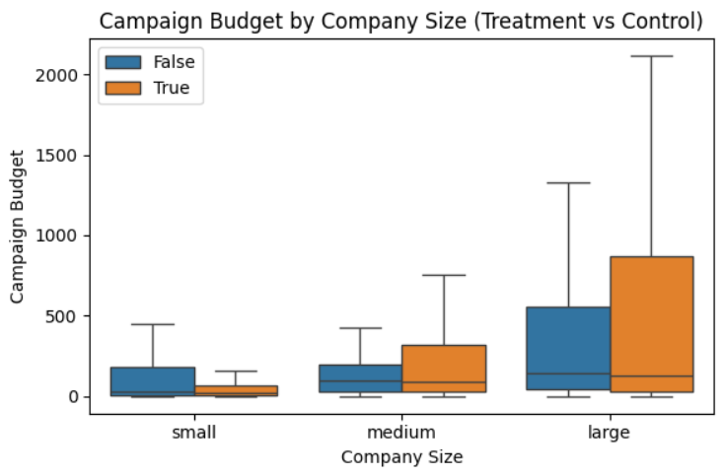
Now we check overall using the following code to see if there is statistical difference:
# Using Mann–Whitney U test to check if treatment group has lower campaign budgets
# H0: Median (control) ≤ Median (treatment)
# H1: Median (control) > Median (treatment)

group_false = df[df["treatment"] == False]["campaign_budget"]
group_true = df[df["treatment"] == True]["campaign_budget"]

stat, p_value = stats.mannwhitneyu(group_false, group_true, alternative='greater') # control > treatment
print(f"p_value: {p_value:.4f}", "|", "significant drop in treatment group" if p_value < 0.05 else "no significant drop")
The output is:
Finally we use Mann Whitney U test for company size to see if the difference is at that level too using the following code:
# H0: Median (control) ≤ Median (treatment)
# H1: Median (control) > Median (treatment)

for company_size in df["company_size"].unique():
group_false = df[(df["company_size"] == company_size) & (df["treatment"] == False)]["campaign_budget"]
group_true = df[(df["company_size"] == company_size) & (df["treatment"] == True)]["campaign_budget"]
stat, p_value = stats.mannwhitneyu(group_false, group_true, alternative='greater') # control > treatment
print(f"company size: {company_size}, p_value: {p_value:.4f}","|", " significant drop in treatment group" if p_value < 0.05 else " no significant drop")
And the output is the following:
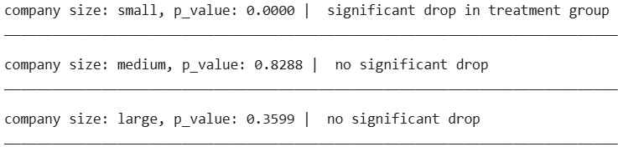
- What is the average overspend percentage for campaigns in both the control and treatment groups?
To find that we can use the following code
breakdown=df.groupby(['treatment'])['overspent_percent'].mean()
breakdown
The output of the code is the following:
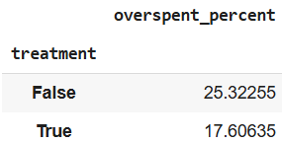
Overspending is less in the Treatment group(17.6%) compared to the control group(25.3%).
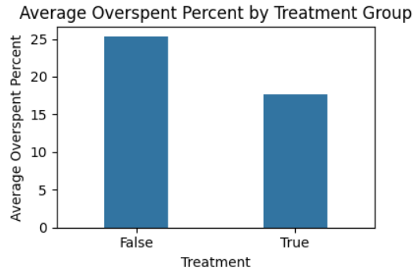
However that maybe a biased number as small company’s overspending maybe more sensitive to percentage change so we use company_size based analysis for mean comparison using the following code:
breakdown=df.groupby(['company_size','treatment'])['overspent_percent'].mean().reset_index()
breakdown
The output will be the following:
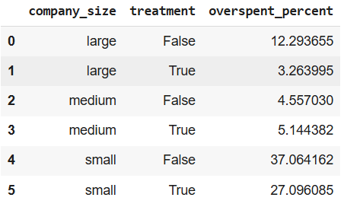
We can also plot the same:
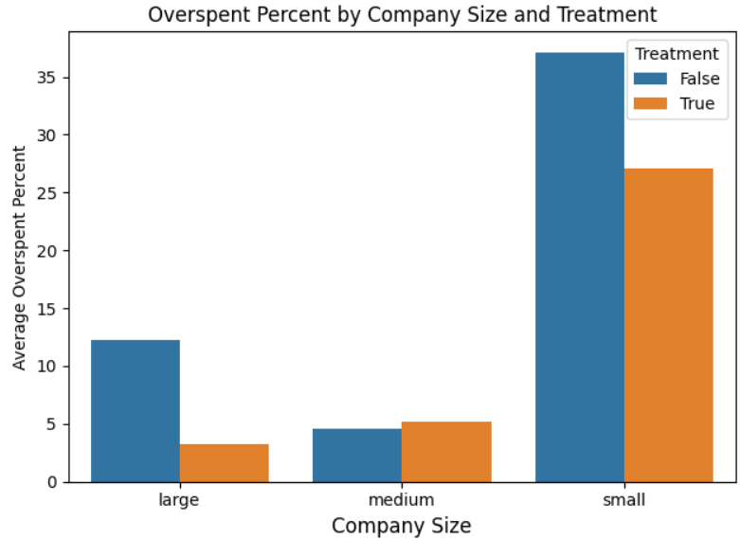
- How does the click-through rate (CTR) compare between the traditional click-based model and the impression-based model?

Click through rates are not given in the data. It is however given that campaign spend depends upon click through rate in the Control group but that is not the case for the Treatment group so we don't have sufficient data to answer the question.
- What demographic factors (company size) correlate with higher overspending rates in both groups?

we use company_size based analysis for mean comparison using the following code:
breakdown=df.groupby(['company_size','treatment'])['overspent_percent'].mean().reset_index()
breakdown
The output will be the following:
We can also plot the same:

- Does company size have a significant impact on the overspend percentage in both control and treatment groups?
To see if the product is effective at company size level first we check if the distribution of each group is normal or not. The code for that is the following:
treatments_iter=df["treatment"].unique()
company_iter=df["company_size"].unique()

for company_size in company_iter:
for treatment in treatments_iter:
stat, p_value=stats.shapiro(df[(df["company_size"]==company_size) & (df["treatment"]==treatment)]["overspent_percent"])

print(f"company size: {company_size},treatment: {treatment}, p_value:{p_value:.2f}", "normally distributed" if p_value>0.05 else "not normally distributed")
The outcome will be the following:
Clearly none of them is normally distributed.
Lets verify it once using hisplot using the following code:
n_rows = len(company_iter)
n_cols = len(treatments_iter)

fig, axes = plt.subplots(n_rows, n_cols, figsize=(10, 8))

for i, company_size in enumerate(company_iter):
for j, treatment in enumerate(treatments_iter):
subset = df[(df["company_size"] == company_size) & (df["treatment"] == treatment)]["overspent_percent"]

# Shapiro wilk's test to check if normal
stat, p_value = stats.shapiro(subset)
normality = "normally distributed" if p_value > 0.05 else "not normally distributed"

ax = axes[i, j]
sns.histplot(subset, kde=True, bins=30, ax=ax)
ax.set_title(f"{company_size} | {treatment} | {normality}")
ax.set_xlabel("overspent_percent")
ax.set_ylabel("Frequency")

plt.tight_layout()
plt.show()
The outcome of the code will also reflect that the distribution of each group is skewed and some have more than 1 peaks
We tried to use log transformation but even then the distribution was not normal.
So it is clear to us that we need to use Mann–Whitney U test instead of T test to see if the difference is statistical difference significant
#using Mann–Whitney U test
# H0: median is same for treatment and control
# H1: median is NOT same for treatment and control

for company_size in df["company_size"].unique():
group_false = df[(df["company_size"] == company_size) & (df["treatment"] == False)]["overspent_percent"]
group_true = df[(df["company_size"] == company_size) & (df["treatment"] == True)]["overspent_percent"]
stat, p_value = stats.mannwhitneyu(group_false, group_true, alternative='greater')
print(f"company size: {company_size}, p_value: {p_value:.4f}", " significant difference" if p_value < 0.05 else " no significant difference")
The output is clear:
For small and large companies, there is a significant difference. But for medium size companies that is not the case.

- Is the variance in campaign spend significantly different between the control and treatment groups?
The variance can be found using group by function using the following code:
group_stats = df.groupby("treatment")["campaign_budget"].agg(["std", "var"])
group_stats
The outcome is as following:
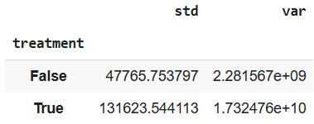
To see if its statistically significant we will have to use levenes test using the following code:
#using levene's test to check if variance or std
#H0: Same variance
#H1: Not same variance
control = df[df["treatment"] == False]["campaign_budget"]
treatment = df[df["treatment"] == True]["campaign_budget"]

stat, p_value = stats.levene(control, treatment, center='median') # 'median' is better as it is skewed data
print(f"Levene’s test p-value: {p_value:.4f}","|", "Significant difference in variance" if p_value < 0.05 else "No significant difference in variance")
The outcome will be the following:
We can also analyse this at the company size level using the following code:
# using Levene's test to check if variance in campaign_budget differs by treatment group within each company size
#H0: Same variance
#H1: Not same variance

for company_size in df["company_size"].unique():
control = df[(df["company_size"] == company_size) & (df["treatment"] == False)]["campaign_budget"]
treatment = df[(df["company_size"] == company_size) & (df["treatment"] == True)]["campaign_budget"]

stat, p_value = stats.levene(control, treatment, center='median') # median is better as it is skewed data
print(f"Company Size: {company_size} | Levene’s p-value: {p_value:.2f}",
"| Significant variance difference" if p_value < 0.05 else "| No significant variance difference")
The outcome of this is:
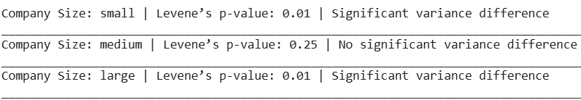
So we can see that the variance is actually different for small and large companies but not in medium sized companies.
